BE NIS2 Law Compliance for Log360

**Tagline** – Automate Belgium NIS2 Law compliance with advanced threat detection and audit reporting using Log360.

**Overview**
The BE NIS2 Law Compliance extension for Log360 helps Belgian organizations and critical infrastructure operators align with the Network and Information Systems Security (NIS2) Directive. By integrating this extension, IT and security teams gain comprehensive visibility into their security posture across all NIS2 requirements.
Log360 continuously collects and correlates log data from Active Directory, Windows, Unix/Linux, Microsoft 365, cloud platforms, and network devices, mapping events directly to NIS2 Law controls. Security teams can track compliance status in real time, investigate incidents quickly, and generate audit-ready reports with a single click.

**Key Features:**
- Generate comprehensive audit-reports mapped to each of the BE NIS2 Law security requirements and controls.
- Correlates logs from different sources to detect threats, anomalies, and suspicious activities with advanced analytics.
- Securely stores and archives logs for customizable retention periods meeting all NIS2 data preservation requirements.
- Export reports in PDF and CSV format for auditors, management, or regulatory submissions.

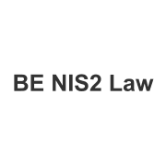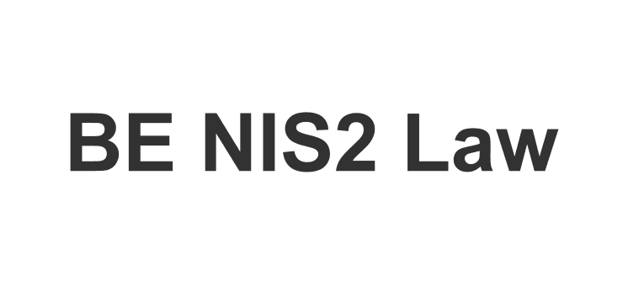
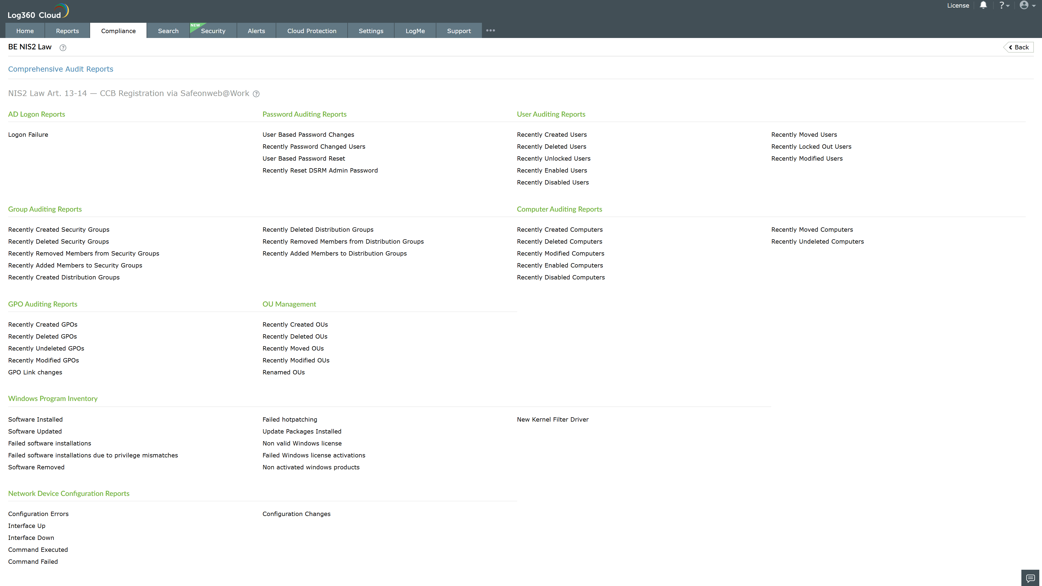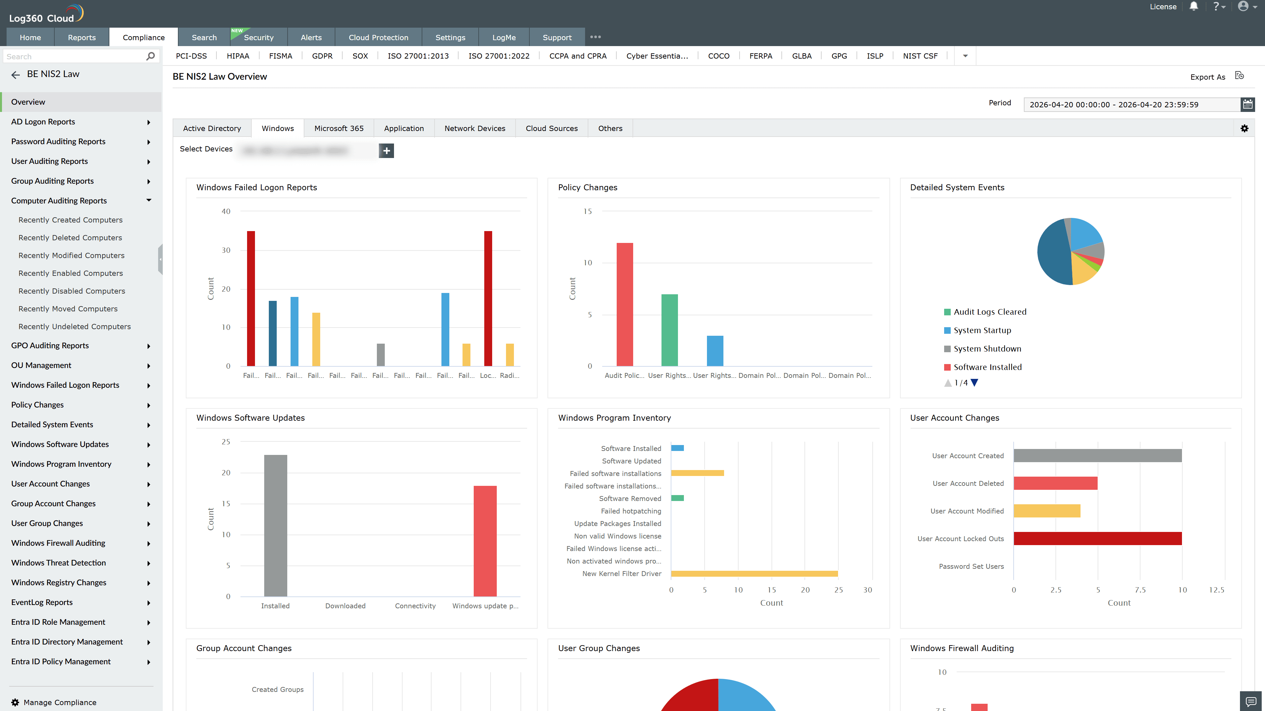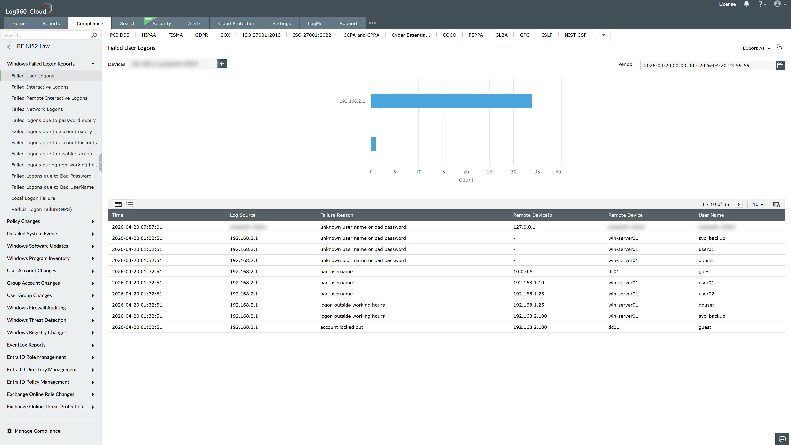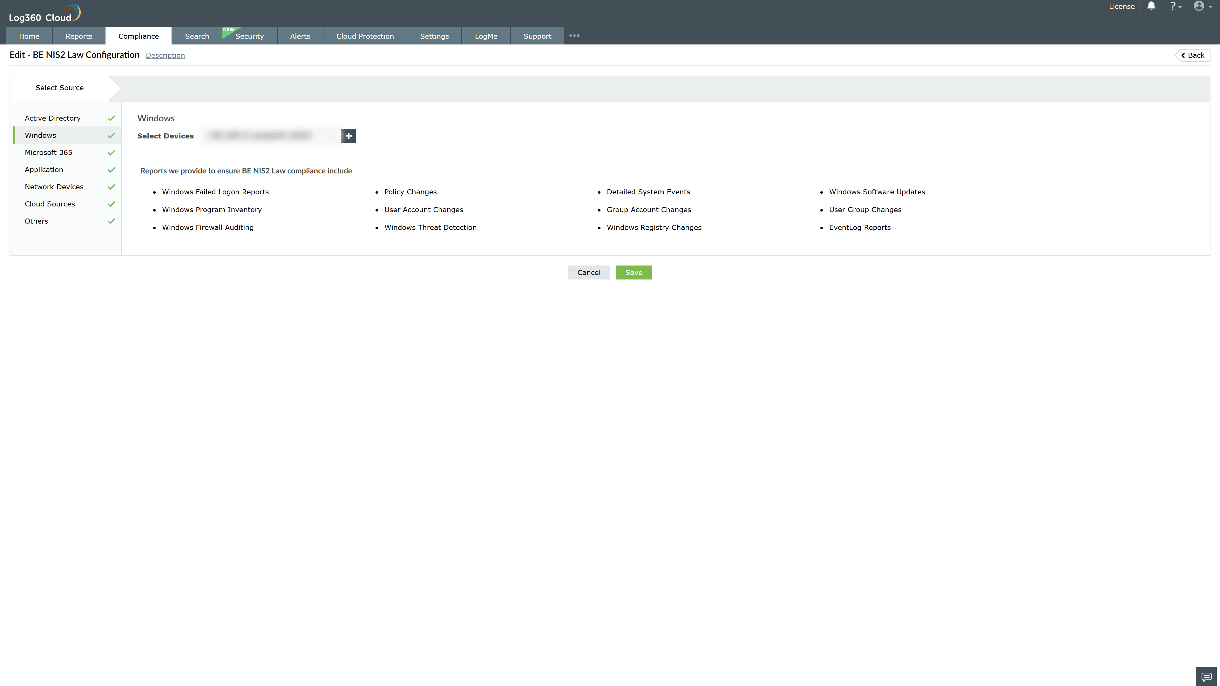
Valid Submission : Yes
Supported Editions : Free, Basic, Standard, Professional, MSSP
Help Document : https://www.manageengine.com/log-management/help/integrations/compliance-extensions.html
Help Video : Not provided
Tags : Log360, Compliance, Privacy monitoring, Data privacy, Regulatory compliance
Supported DCs : US, IN, JP, CA, AU, UK and EU
Privacy Policy:
Terms of Service:
Release Notes:
Predefined reports for the BE NIS2 Law Compliance.

